**Humptys House Pre-School and Kool Kidz Club**

**Equality Statement**

**We ensure that:**

**Everyone is treated as an individual**

**Everyone is treated equally**

**Everyone learns to respect themselves and each other**

**Everyone has the right to fulfil their potential**

**Everyone has the right to feel safe and secure**

**Everyone will make a difference**

**You too can be involved**

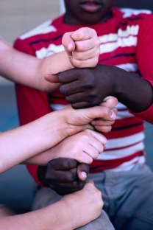 **C:\Documents and Settings\Owner\Local Settings\Temporary Internet Files\Content.IE5\FMSTCK5M\MC900244233[1].wmf C:\Documents and Settings\Owner\Local Settings\Temporary Internet Files\Content.IE5\PCLF8UN2\MC900047964[1].wmf** 